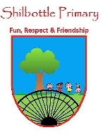
Science – Electricity
00
Knowledge
Electricity is an energy. This energy can be used to power electrical items such as toasters, kettles, cookers, televisions and computer tablets.
Electrical energy is caused by electrons (the particles in atoms) moving about to make a current.

The diagram shows a battery (cell) with wires connecting it to the bulb.
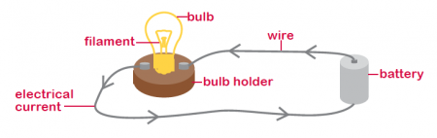
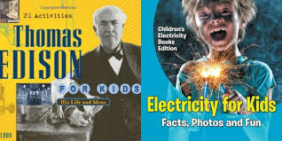
Books

Skills
- Build circuits to power appliances.
- Group materials according to their insulating or conducting properties.
- Design an experiment to see what impacts the brightness of a bulb.
- I can identify components of a circuit and their purpose.
Vocabulary | Meaning
appliance | A piece of equipment designed to perform a specific task.
battery | A container containing chemical energy that is converted to electrical energy and used as a source of power.
battery-powered | An appliance that works using batteries.
circuit | Made up of individual electrical components joined by wires to allow electricity to flow through and power and appliance.
component(s) | A piece of the electrical circuit. (e.g. bulb or buzzer)
conductor | A material that allows heat or electricity to pass through it.
electricity | A form of energy that can power appliances.
insulator | A material that does not allow heat or electricity to pass through.
mains-powered | An appliance that has to be plugged into the wall to work.
plug | Rocks are made up of grains that are packed together.
switch | A device to make an electrical connection between the appliance and the mains (socket in the wall).
wires | Thin strips of metal used to pass electrical currents through.
What I should be able to do and know now.
Key skills in Science

What I will know and be able to do at the end of the topic.

Knowledge
- I know that a battery makes things work.
- I know that electricity comes out of plug sockets.
- I know that wires carry electricity.
- Electricity can be dangerous if not used correctly.
- A bulb is something that creates light.
- Batteries can run out and need replacing.

Skills
- I can draw diagrams and label them correctly.
- I can name objects that use batteries.
- I can name objects that required plug sockets to work.
- I can observe differences in an experiment.
- I design an experiment to test something.

Knowledge
- Name 3 different components of a circuit and what they do.
- A complete circuit is when there is no g____ in the connections between the components.
- To make a light bulb brighter, what should you change in a circuit?
- A conductor is a material that a______ electricity to pass through.
- An insulator is a material that d_____ a______ electricity to pass through.
- Name 3 metals that are conductors.
- Name 3 materials that are insulators.

Skills
- I can draw an electrical circuit correctly.
- I can use symbols for the components in the circuit.
- I can carry out an experiment to test what impacts on bulb brightness.
- Design functional products based on the properties of the materials.

- I can make systematic and careful observations.
- I can set up some simple practical enquiries, including comparative tests.
- I am beginning to collect data in a variety of ways, including labelled diagrams, bar charts and tables.
- I am beginning to talk about and identify differences and similarities in the properties of materials.
- I am beginning to identify simple changes related to simple scientific phenomena.
- I am beginning to discuss criteria for grouping and sorting and can classify using a simple key.

What I will be learning
- To investigate circuits and their different components.
- To investigate the differences between mains and battery-powered circuits.
- To recognise some common conductors and insulators, and associate metals with being good conductors.
- To investigate the purposes of conducting and insulating materials.
- To be able to use knowledge of conductors and insulators to create switches to complete a circuit.
- To be able to plan and carry out an experiment to see how to change the brightness of a bulb.

