

**PSHE – Dreams & Goals**

**Vocabulary**

**Skills**

**Books**

* To be able to see a situation from different viewpoints.
* To analyse the choices people may make in a situation and why this may be,
* Give evidence/ reasoning to support my decisions.
* To predict the consequences (positive and negative) of a decision.

Means not good, or to be negative.

**bad**

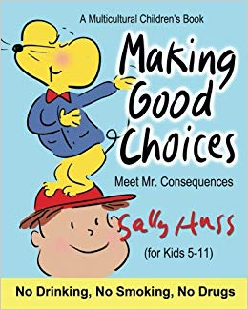

To have options to choose from.

**choice**

When there is disagreement over something.

**conflict**

The impact of an action or event, often negative.

**consequences**

**Knowledge**

To choose an option and decide on it.

**decision**

Something positive.

**good**

**By the end of this topic you will learn:**

* That making choices comes with consequences, and these can be both positive and negative.
* Not everybody will make the same choice, and to think about the reasons for and why this may be.
* To understand that making a decision comes with analysing the impacts of that decision for me and the people involved, in order to make the right choice.

Telling the truth about your thoughts and feelings.

**honesty**

To hear what someone else is saying.

**listening**

A situation with an issue that needs to be resolved.

**problem**

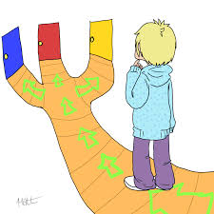

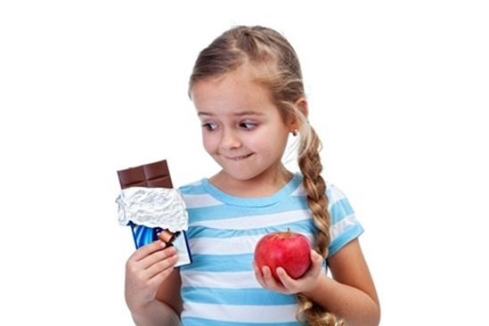

The solving of a problem.

**resolution**

The best thing to do, what is acceptable by others.

**right**

Doing something that people do not agree with.

**wrong**

**What I should be able to do and know now.**

**What I will know and be able to do at the end of the topic.**

**Key skills in PHSE**

**Knowledge:**

* Good choices have _________ consequences.
* Bad choices have ___________ consequences.
* To make a choice I must consider the c____________ for both me and other people involved.
* Can you describe a situation where you made a good choice? What were the consequences of this choice?
* Can you describe a situation where you made a bad choice? What were the consequences of this choice?

**Skills:**

* To see a situation from other peoples’ viewpoints, to assess the consequences for all involved.
* To analyse the consequences of a choice to decide on positive and negative choices.
* Explain my reasons/ justify a choice I have made and why I believe this is a good choice for the situation.
* Making decisions and choices.
* Managing pressure and stress.
* Managing risk and personal safety.
* Active listening.
* Analysing and evaluating situations.
* Communicating ideas and views to others.
* Self-reflection Managing risk and personal safety.
* Setting challenging goals for self.

**Knowledge:**

* To know that sometimes we have choices and we have to make a decision.
* To know what I would do in a situation and why this may be.
* To know that it is important to listen to other people involved in the decision making.
* Some choices are good and some choices are bad.

**Skills:**

* To listen to other peoples’ points of view on a situation.
* To choose an option when given a choice.
* Describe how someone might feel in a situation.

**What I will be learning**

* That making choices impacts other people and not just me.
* Choices come with consequences that can be positive and negative.
* To make a good choice I have to think about the consequences that choice will have for me and the other people involved.
* A conflict is when there is disagreement and this can make a choice hard to make.
* Making the right choice is important and the right choice will have positive consequences.