

**Science - Sound**

**Meaning**

**Vocabulary**

**Skills**

**Books**

A device used to make a buzzing sound.

* To be able to draw diagrams to represent sound waves.
* To compare pitch and volume of sounds.
* To draw graphs to show how distance effects sound.
* To explain how sound travels through the air and other materials.

**buzzer**

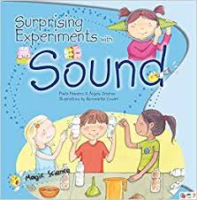

A measurement of length to describe how far it is to a place or thing.

**distance**

A musical instrument with keys that you tap with a beater to make sounds.

**glockenspiel**

An object that is used to create music.

**instrument**

**Knowledge**

How high or low a sound is.

**pitch**

* Sounds can be of different pitch and volumes.
* A sound travels through air in sound waves.
* Sound waves cannot be seen but cause vibrations in materials.
* Instruments work because of vibrating air.

A noise produced by vibrating air.

**sound**

Used to describe the width of the strings on an instrument.

**thickness**

Used to describe how much tension (how tight) the strings on an instrument have.

**tightness**

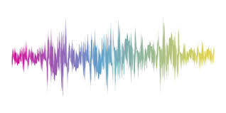

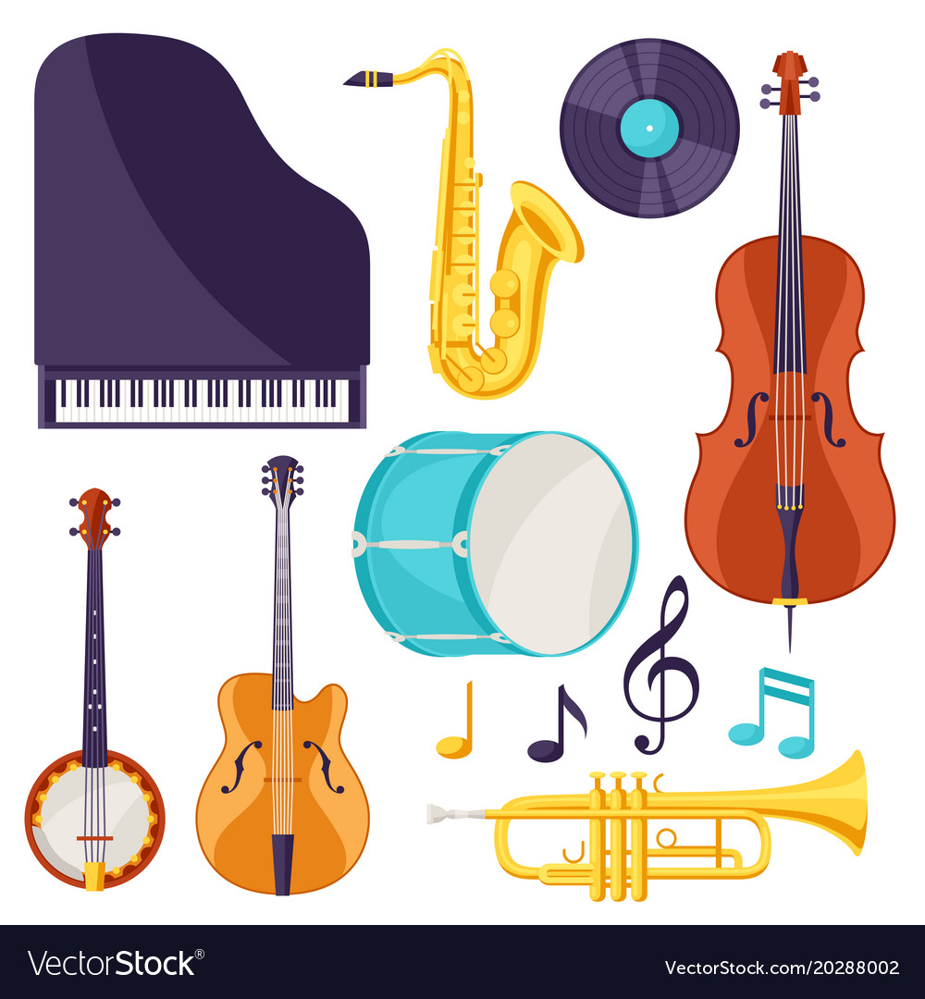

Particles moving together and bumping into each other.

**vibrate**

Repeated waves of a vibration.

**vibrations**

A measurement of how loud or quiet a sound is.

**volume**

**xylophone**

An instrument with keys that makes sounds when it is hit with a beater.

**Key skills in Science**

**What I will know and be able to do at the end of the topic.**

**What I should be able to do and know now.**

**Knowledge:**

* To know that sounds are noises.
* To know that sounds travel through air.
* To know that our ears help us to hear sounds.
* To know that we cannot see sounds but we listen to them.
* To know that sounds can be quiet or loud.

**Skills:**

🞄Make different sounds using the notes of an instrument.

🞄Draw a diagram of an instrument and label it.

🞄Explain what sound is and give examples of things that make loud sounds and things that make quiet sounds.

**Knowledge:**

**Can you explain how sounds are made?**

**What causes sounds?**

When the p_________ in an object v__________ it causes the a_____ to v______ which passes on the sound w_______.

**Pitch is how _______ or ________ a sound is.**

**Volume is how _______ or _______ a sound is.**

**Pitch can be affected by the _________, _________or ________ of a string.**

**Can you explain how you would test materials to see if they allow sound to pass through? How would you make it a fair test?**

**Skills:**

Draw a diagram showing sound waves and how they travel.

Create a graph to show how distance effects volume.

Explain how pitch can be changed and describe an experiment to test this.

Use instruments to make sounds with different volumes and pitches.

* I can make systematic and careful observations.
* I can set up some simple practical enquiries, including comparative tests.
* I am beginning to collect data in a variety of ways, including labelled diagrams, bar charts and tables.
* I am beginning to talk about and identify differences and similarities in the properties of materials.
* I am beginning to identify simple changes related to simple scientific phenomena.
* I am beginning to discuss criteria for grouping and sorting and can classify using a simple key.

**What I will be learning**

* To find out that sounds are made when objects and materials vibrate.
* To investigate whether sounds can travel through different materials.
* To explore the relationship between distance and volume.
* That some materials are effective in preventing vibrations from sound sources reaching the ear.
* To investigate how sounds can be different pitches and volumes.
* To find out how the length, thickness and tightness of a string affects its pitch.
* To find out how sounds can be made by air vibrating and how to change the pitch of notes produced by vibrating air.