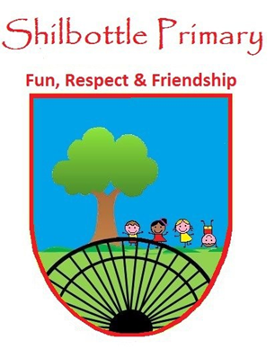
Year 3 Spelling List – Spring 2

Spelling lists for this term are given below. Each week children will have 6 spellings following a spelling rule and 4 spellings from the expected to know lower KS2 words. Children will be tested on these spellings on a Friday in class.
Spelling Homework: To be completed in Homework book. Children are to write out the words in a list and then write a sentence using each word (10 sentences in total).

Week 1  Test date 4/3/22 | Week 2  Test date 11/3/22 | Week 3  Test date 18/3/22
Spelling rule  Adding the prefix super-  supermarket  Superman  superstar  superpower  superhero  superhuman  Lower KS2 spellings  occasion  occasionally  often  opposite | Spelling rule  Adding the prefix sub-  subway  submarine  subtitle  submerge  subdivide  subsoil  Lower KS2 spellings  ordinary  particular  peculiar  perhaps | Spelling rule  Adding the prefix dis- and in-  disappear  dislike  disappoint  independent  incorrect  invisible  Lower KS2 spellings  popular  position  possess  possession
Week 4  Test date 25/3/22 | Week 5  Test date 1/4/22 | Week 6  Test date 8/4/22  Spelling rule  Lower KS2 words from the year so far  actual  address  answer  breathe  believe  different  consider  circle  decide  caught
Spelling rule  Spelling rule words from the term  supermarket  submerge  subtitle  disappear  incorrect  disappoint  subdivide  Superman  submarine  independent | Spelling rule  Lower KS2 words so far this year  breath  accidentally  difficult  eighth  height  knowledge  business  caught  bicycle  February

