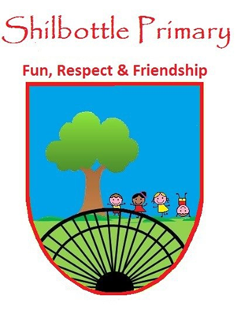
Year 3 Spelling List – Summer 1

Spelling lists for this term are given below. Each week children will have 6 spellings following a spelling rule and 4 spellings from the expected to know lower KS2 words. Children will be tested on these spellings on a Friday in class.
Spelling Homework: To be completed in Homework book. Children are to write out the words in a list and then write a sentence using each word (10 sentences in total).

Week 1  Test date 29/4/22 | Week 2  Test date 6/5/22 | Week 3  Test date 13/5/22
Spelling rule  Adding the suffix -ous  fabulous  dangerous  nervous  continuous  famous  generous  Lower KS2 spellings  promise  purpose  quarter  question | Spelling rule  Adding the suffix -ly  actually  carefully  suddenly  differently  generously  dangerously  Lower KS2 spellings  recent  regular  reign  remember | Spelling rule  Words ending in -ture  adventure  creature  future  picture  nature  departure  Lower KS2 spellings  sentence  separate  special  straight
Week 4  Test date 20/5/22 | Week 5  Test Date 27/5/22 | Helping your child to practice can be done by testing them throughout the week or by using a range of activities such as pyramid spellings, rainbow writing, forwards and backwards writing.  A set of cards using these activities will be sent home at the start of the year.
Spelling rule  Adding the prefix im-  impossible  immobile  immature  impolite  impatient  imperfect  Lower KS2 spellings  certain  circle  complete  consider | Spelling rule  Adding the suffix -ly  sadly  completely  usually  finally  comically  quickly  Lower KS2 spellings  continue  decide  describe  different

