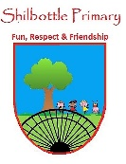

**Geography – Year 6 – spring 1 – Trade and Economics**

**Vocabulary**

**Skills**

**Books**

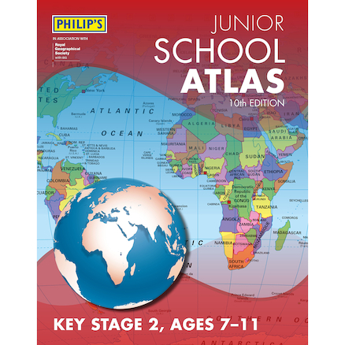 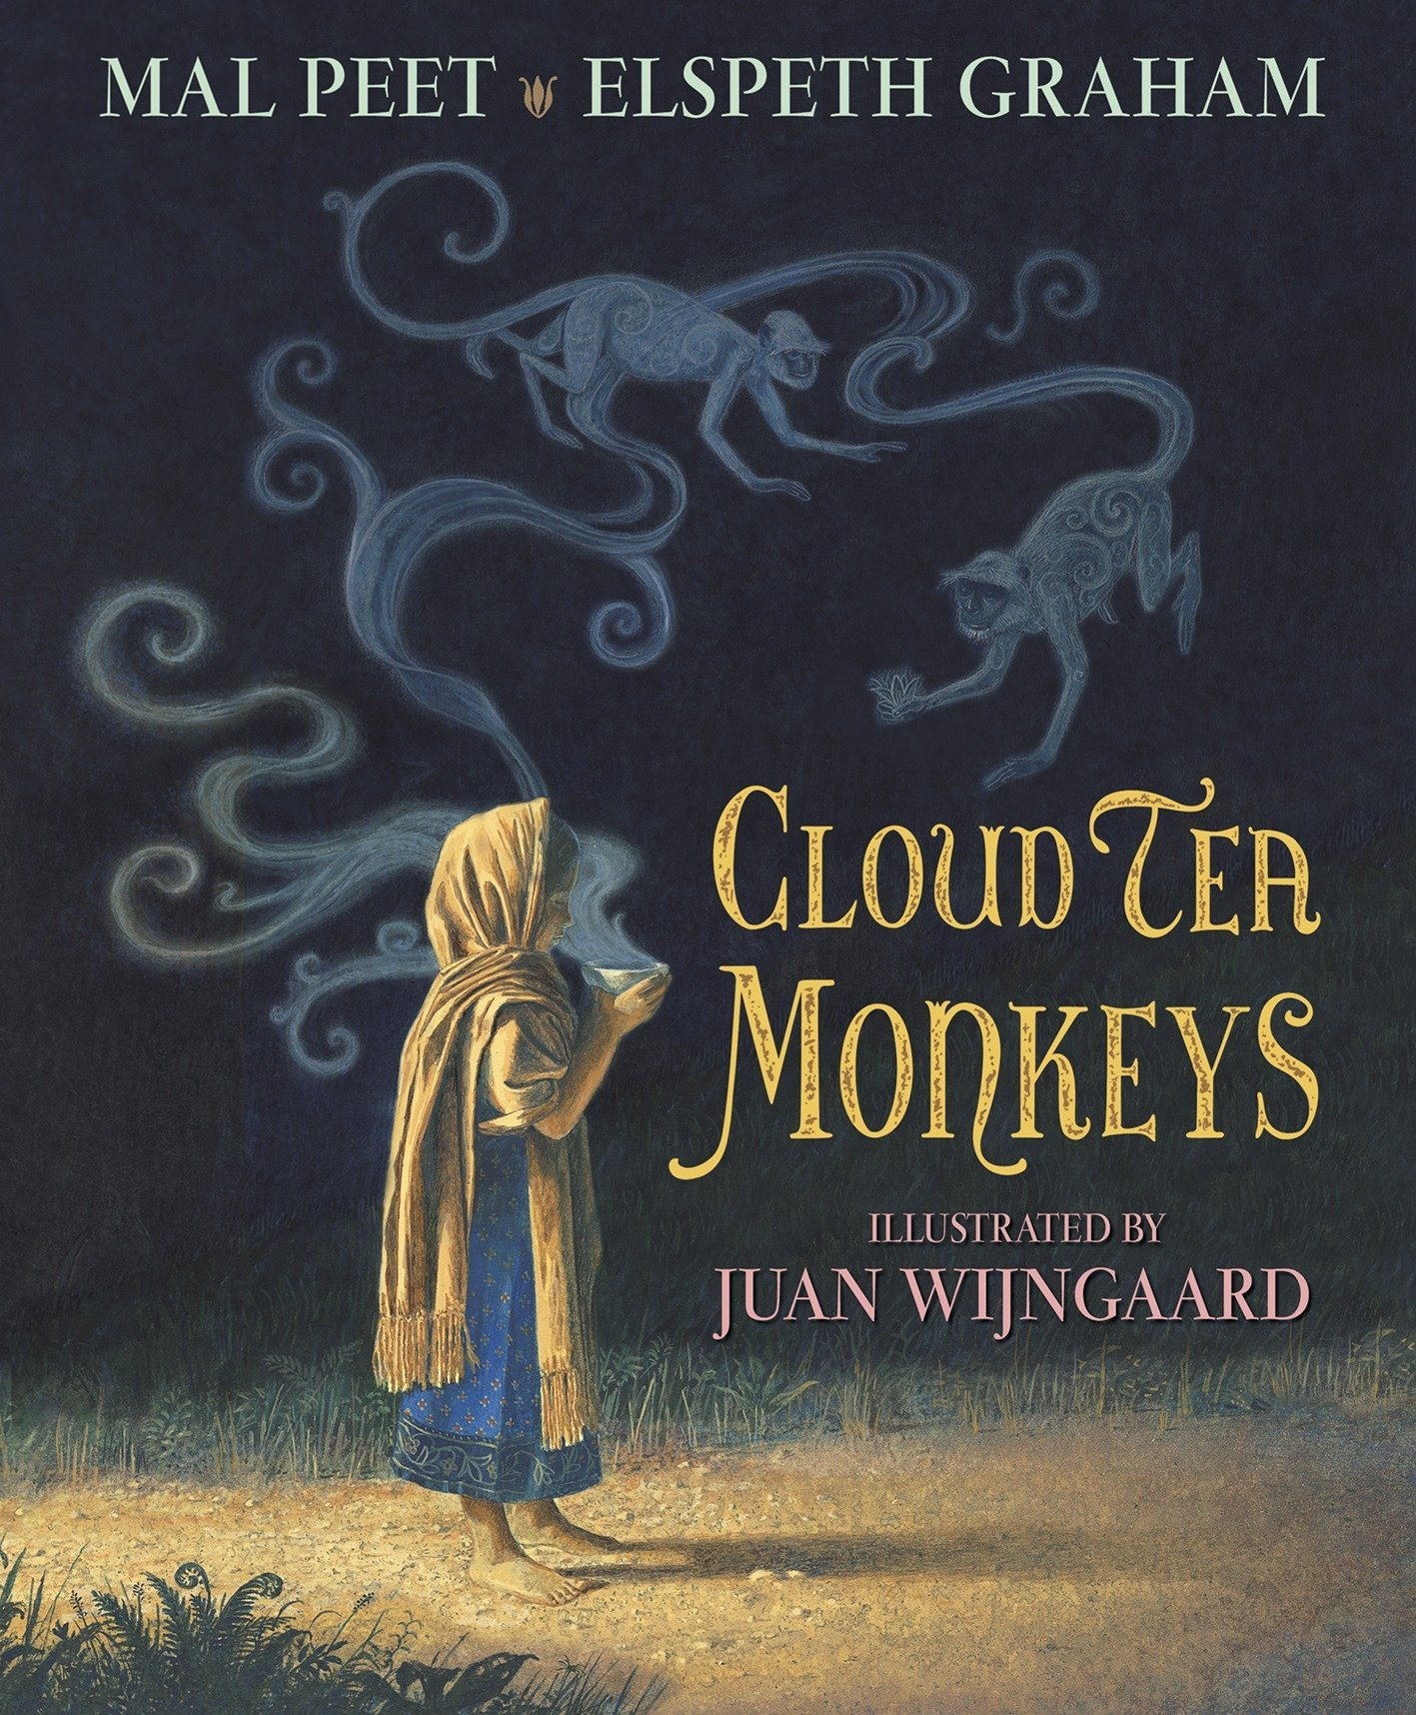

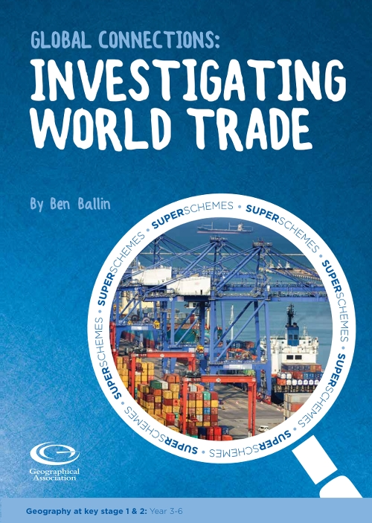 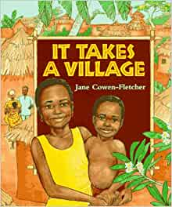

Use and create maps to locate and describe features studied.

Use fieldwork to observe, measure and record the human and physical features in the local area.

Compare different sources of information and decide which is more reliable.

Identify similarities and differences between trading today and different periods in history.

How money is made and spent in a particular area.

**economy**

Goods or services made in the UK and sold to another country.

**export**

Around the world.

**global**

The spread of trade and ideas worldwide.

**globalisation**

**Knowledge**

Different places a product and its parts come from, and travel to, on its way to a consumer.

**global supply chain**

Items that can be bought and sold. Sometimes they are called products.

**goods**

**Trade** has changed a lot through history. This is partly due to developments in transportation, but also due to the changing relationships of the UK with other countries. In Tudor times, the UK **traded** with the Americas, whereas in Victorian times, the UK mainly **traded** with other countries who were in the British Empire.

The UK trades a lot of **goods** and **services**. Some of the goods the UK **exports** are: scrap iron, whisky, tartan kilts, medicines, aircraft parts, cars, oil and gas. Some of the goods the UK **imports** are: coffee beans, bananas, medicines, aircraft parts, cars, computers, oil and gas.

**Globalisation** has meant that more and more **goods** travel around the world before being sold in a shop. Sometimes, parts of a **product** are made in several different countries before being assembled in another one. There are many steps involved in selling **goods**. Bananas, for example, are generally grown on plantations, where the owner has to take care of the ground. Fruit pickers harvest the fruit before **exporters** transport the bananas by ship. **Importers** then transport the bananas before the retailer sells them in shops.

A map reference indicating a location in terms of a series of vertical and horizontal grid lines identified by letters or numbers.

**grid reference**

Goods or services purchased from one country and brought into the UK.

**import**

Great Britain’s national mapping agency.

**Ordnance Survey**

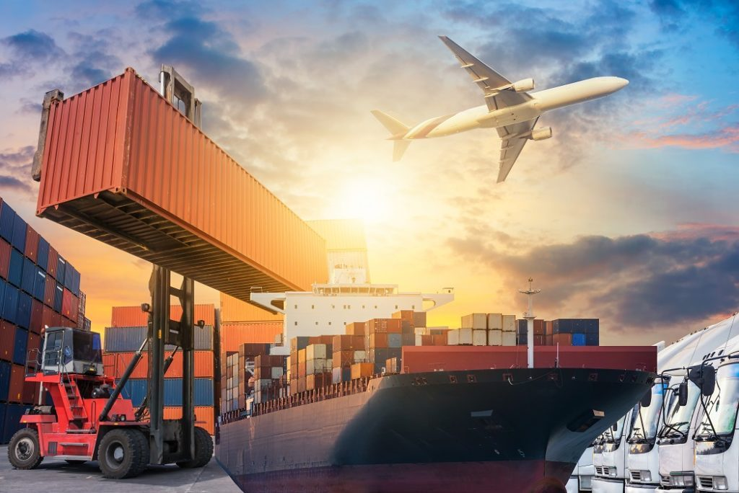

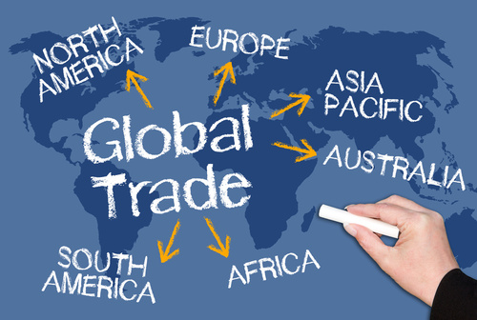

An article or substance that is manufactured or refined for sale.

**products**

A system supplying a public need such as transport or communications.

**services**

The action of buying and selling goods and services.

**trade**

**What I should be able to do and know now.**

**What I will know and be able to do at the end of the topic.**

**Concepts Links**

**Knowledge:**

* Shilbottle provides more services than goods because …
* Shilbottle provides more services than goods, but …
* Shilbottle provides more services than goods, so …
* Coffee beans need to be imported to the UK because …
* Coffee beans need to be imported to the UK, but …
* Coffee beans need to be imported to the UK, so …
* Trade links are important with El Salvador because …
* Trade links are important with El Salvador, but …
* Trade links are important with El Salvador, so …

**Skills**

* The grid references at the bottom of a map are called Eastings because …
* The grid references at the bottom of a map are called Eastings, but …
* The grid references at the bottom of a map are called Eastings, so …
* A 6-figure grid reference gives more information because …
* A 6-figure grid reference gives more information because, but …
* A 6-figure grid reference gives more information because, so …

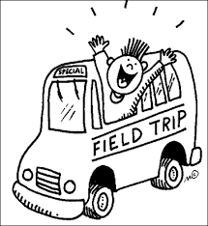 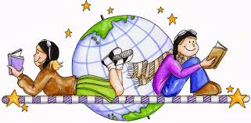 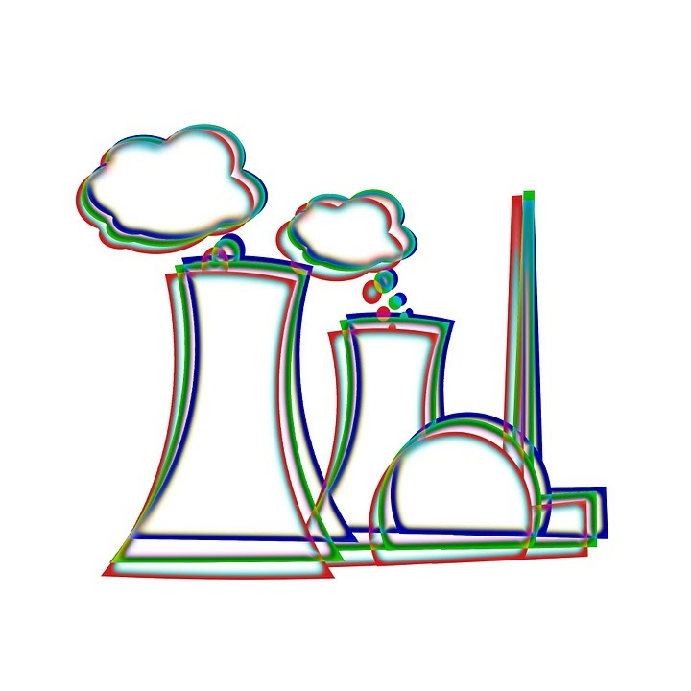

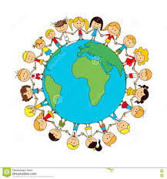 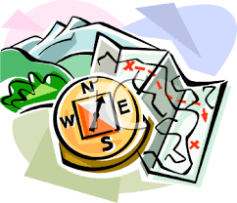

**Knowledge:**

* Identify seasonal and daily weather patterns in the UK.
* Use basic geographical vocabulary to identify and describe key human and physical features.
* Name and locate the world’s seven continents and five oceans.
* Describe different types of settlement and land use.
* An understanding of different **climate zones** around the world.
* Use the key to interpret symbols and marks on an OS map for routes.
* Use longitude and Latitude as a guide to a location on an atlas.

**Skills:**

* Collect information about the local area.
* Use a range of sources to compare places.
* Follow directions on a map (including on an OS map); draw a route showing features.
* Compare a region of the UK, a region of an European country and a region within North or South America.
* Create a survey to explore human or physical features in the local area.
* Read and interpret the globe as a flat map.
* Identify and interpret relief maps.
* Locate places on an OS map using a 4-figure grid reference.
* Use photographs and measurements to create an accurate map of an area.

Human geographical features

Location Knowledge

Field Trips

Map Skills

Place Knowledge

**What I will be learning**

1. I am learning to plan a route around my local area using a digital map.
2. I am learning to locate significant human features, on an OS map, in my local area.
3. I am learning to analyse information gathered on a field trip.
4. I am learning to explain the UK’s trade links with other countries.
5. I am learning to explain the UK’s trade links with other countries and show them on a map.
6. I am learning to explain trade links between El Salvador and the UK and researching issues faced by people from both countries.