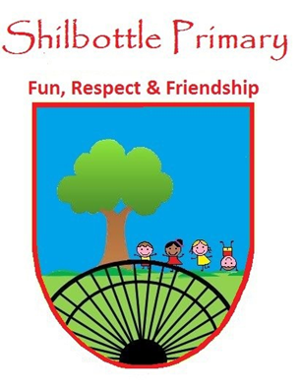
Year 3 Spelling List – Summer 2

Spelling lists for this term are given below. Each week children will have 6 spellings following a spelling rule and 4 spellings from the expected to know lower KS2 words. Children will be tested on these spellings on a Friday in class.
Spelling Homework: To be completed in Homework book. Children are to write out the words in a list and then write a sentence using each word (10 sentences in total).

Week 1  Test date 10/6/22 | Week 2  Test date 17/6/22 | Week 3  Test date 24/6/22
Spelling rule  Homophones  where wear  there their they’re  write right  meet meat  beat bare  break brake  Lower KS2 spellings  strange  strength  suppose  surprise | Spelling rule  Adding –ation to verbs to form nouns  sensation  explanation  preparation  information  temptation  plantation  Lower KS2 spellings  therefore  though  thought  through | Spelling rule  Adding the prefix dis- and in-  disappear  dislike  disappoint  independent  incorrect  invisible  Lower KS2 spellings  popular  position  possess  possession
Week 4  Test date 1/7/22 | Week 5  Test Date 8/7/22 | Week 6  Test Date 15/7/22
Spelling rule  Lower KS2 words so far this year  material  naughty  surprise  various  weight  woman  possible  ordinary  continue  length | Spelling rule  Lower KS2 words so far this year  opposite  perhaps  experiment  exercise  imagine  experience  increase  decide  certain  busy

