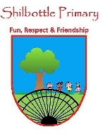

**P.S.H.E. – Healthy Me.**

**Skills**

* Able to set themselves a fitness challenge.
* Recognise what it feels like to make a healthy choice.
* Identify how they feel about drugs.
* Can express how being anxious or scared feels.
* Can take responsibility for keeping themselves and others safe.
* Respect their own bodies and appreciate what they do.

**Knowledge**

In this Puzzle you will talk about the importance of exercise and how it helps your body to stay healthy. You will also talk about your heart and lungs, discuss what they do and why they are very important. You will learn about calories, fat and sugar; discuss what each of these are and how the amount you consume can affect your health. You will learn about different types of drugs; the ones you take to make you better as well as other drugs. You will think about things, places and people that are dangerous linking this to strategies for keeping yourself safe.

 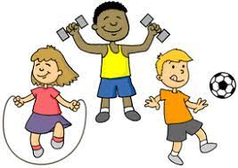

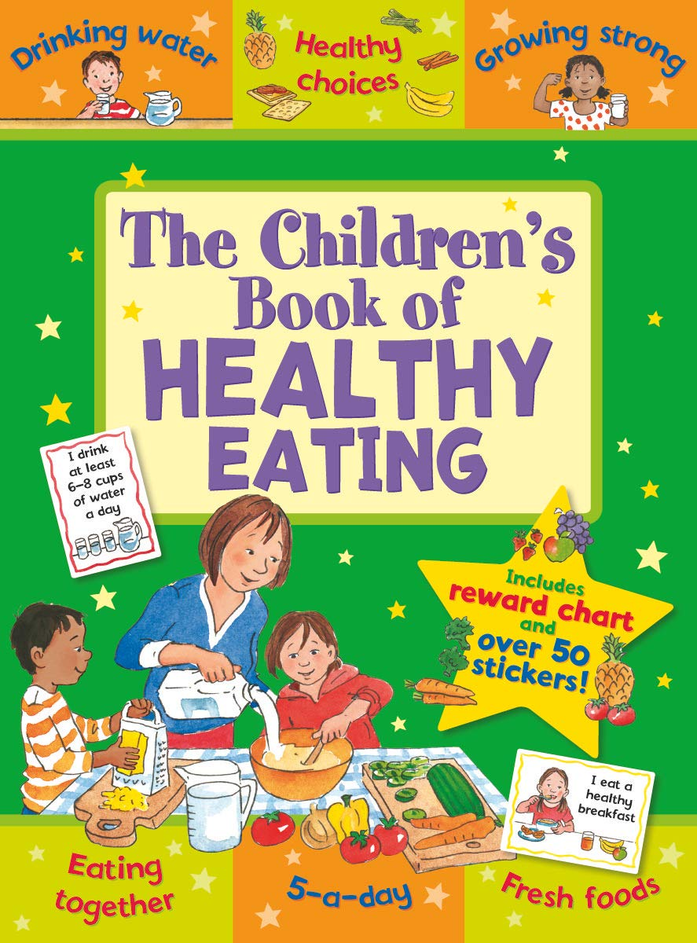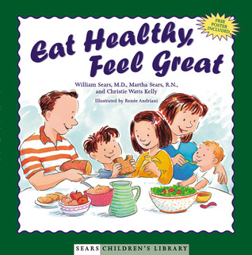

**Books**

|  |  |
| --- | --- |
| Vocabulary | Meaning |
| **anxious** | Feeling or showing worry, nervousness, or unease about something with an uncertain outcome. |
| **appreciate** | To be grateful for something and realise it is important to you. |
| **attitude** | The way you demonstrate your thinking or opinion of something. |
| **body** | The physical structure, including the bones, flesh, and organs, of a person or an animal. |
| **choice** | When you are given options and must choose. Choices can lead to positive or negative consequences. |
| **drugs** | Substances that you put into your body. These can either make you better or damage your body. |
| **fitness** | When your body is in good healthy as you exercise regularly. |
| **heartbeat** | The amount of times your heart beats, often recorded as the number of beats per minute. |
| **oxygen** | The gas in the air that we breathe in. |
| **safe** | A thing, situation or place that is not going to cause you damage or harm. |
| **saturated fat** | A type of fat that is less healthy in your diet. It is bad for your body. |
| **strategy** | A plan to achieve a target or be successful at something. |

**What I will know and be able to do at the end of the topic.**

**Key skills in PHSE**

**What I should be able to do and know now.**

**Knowledge**

How does exercise affect your body? Explain.

The role of your heart is to _________ and the role of your lungs is to _____________.

What is a drug? Can you give an example?

Can you name a place, thing or person that might be dangerous? How would you remain safe from this?

Can you describe an exercise that would help you to get fit?

**Skills**

I can demonstrate how to do exercise.

I can recognise dangerous things, places or people.

I can be responsible for keeping myself safe.

I can work in a group.

I can explain the function of the heart and lungs.

I can respect others’ opinions.



**Knowledge**

I know that exercise is good for you.

I know that I have a heart and some lungs.

I know that too much sugar and fat are bad for your body.

I know that some things are dangerous to eat.

I know that dangerous means it could be harmful.

**Skills**

I can sit and listen.

I can give my opinion.

I can repeat an action.

I can take my turn.

I can work with a partner.

**What I will be learning**

* Know how exercise affects their bodies and that their bodies are complex and need taking care of.
* Know why their hearts and lungs are such important organs.
* Know that the amount of calories, fat and sugar that they put into their bodies will affect their health.
* Know that there are different types of drugs.
* Know that there are things, places and people that can be dangerous.
* Know a range of strategies to keep themselves safe.
* Know when something feels safe or unsafe.