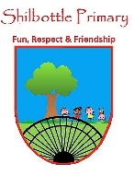

**Science - Year 6 – spring 1 - Animals Including Humans**

**Books**

**Skills**

**Meaning**

**Vocabulary**

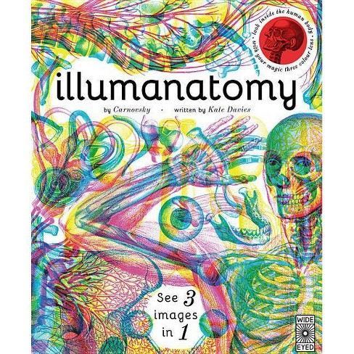

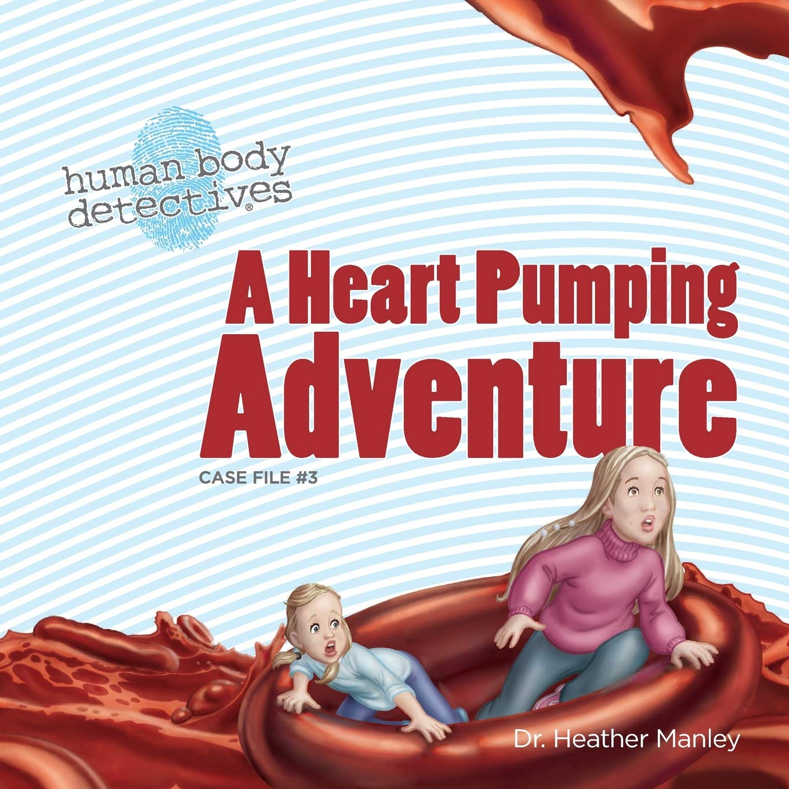

🞄Plan different types of scientific enquiries to answer questions, including recognising and controlling variables where necessary.

🞄Take measurements, using a range of scientific equipment, with increasing accuracy and precision, taking repeat readings where necessary.

🞄Identifying scientific evidence that has been used to support or refute ideas or arguments.

🞄Use test results to make predictions to set up further comparative tests.

Large vessels that carry oxygenated blood from the heart around the body.

**arteries**

**capillaries**

Small blood vessels which enable the moving of water, oxygen and carbon dioxide between blood and tissue.

The body’s delivery system. Made up of the heart, blood and blood vessels.

**circulatory system**

Any drug which changes or alters our physical or mental state.

**drug**

**Knowledge**

🞄The **circulatory system** is made of the **heart, lungs** and **blood vessels.**

🞄**Arteries** carry **oxygenated** blood from the **heart** to the rest of the body.

🞄**Veins** carry **deoxygenated** blood from the body to the **heart.**

🞄**Nutrients, oxygen** and **carbon dioxide** are exchanged **via** the **capillaries.**

🞄Some choices, such as smoking and drinking alcohol can be harmful to our health.

🞄Tobacco can cause short-term effects such as shortness of breath, difficulty sleeping and loss of taste and long-term effects such as lung disease, cancer and death.

🞄Alcohol can cause short-term effects such as addiction and loss of control and long-term effects such as **organ** damage, cancer and death.

🞄Exercise can: tone our muscles and reduce fat; increase fitness; make you feel physically and mentally healthier; strengthens your **heart**; improves **lung** function; improves skin.

A muscle that contracts to extend a limb or joint.

**extensor**

A muscle that contracts to bend a limb or joint.

**flexor**

A muscle which pumps blood and keeps blood moving around the body.

**heart**

Air sacks that allow the blood to absorb O2 and release CO2.

**lungs**

A drug for the treatment or prevention of disease.

**medicine**

**muscles**

Small, stretchy fibres grouped together and attached to bones.

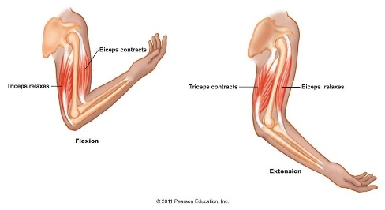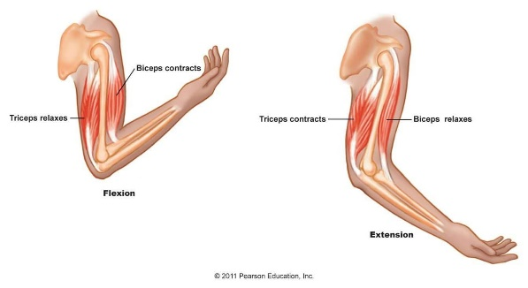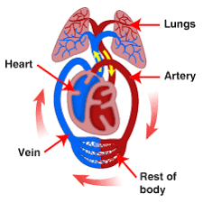

**veins**

Blood vessels that carry de oxygenated blood back to the heart.

**Concept Links**

**What I should be able to do and know now.**

**What I will know and be able to do at the end of the topic.**

**Knowledge:**

Platelets in our blood have an important function because …

Platelets in our blood have an important function, but …

Platelets in our blood have an important function, so …

The pulmonary circulation part of the heart is important because …

The pulmonary circulation part of the heart is important, but

The pulmonary circulation part of the heart is important, so …

The blood is pumped out of the right ventricle and into the pulmonary artery because …

The blood is pumped out of the right ventricle and into the pulmonary artery, but …

The blood is pumped out of the right ventricle and into the pulmonary artery, so …

Nicotine and alcohol are very addictive drugs because …

Nicotine and alcohol are very addictive drugs, but …

Nicotine and alcohol are very addictive drugs, so …

**Skills:**

It is important to record your resting pulse rate accurately because …

It is important to record your resting pulse rate accurately, but …

It is important to record your resting pulse rate accurately, so …

 

https://lh5.googleusercontent.com/_FBPHvCLSTpxAf4Pva7t3YGqKr3XqKKlJtPlUI1lnWU05smtzok_tDzYRtZi0pxMgZNrRO-6JPRVvszS9KL6C5wd6sMSUY07w3PRAxHwM852xc7wB2jln1vy5vi7ShjTa3GjZKH9 

**Knowledge:**

🞄Which things are living and which are not.

🞄Classification of animals (e.g. amphibians, reptiles, birds, fish, mammals, invertebrates).

🞄Animals that are carnivores, herbivores and omnivores.

🞄Animals have offspring which grow into adults.

🞄The basic needs of animals for survival (water, food, air).

🞄The importance of exercise, hygiene and a balanced diet.

🞄Animals get nutrition from what they eat.

🞄Some animals have skeletons for support, protection and movement.

🞄The basic parts of the digestive system.

🞄The different types of teeth in humans.

🞄Respiration is one of the seven life processes.

🞄The life cycle of a human and how we change as we grow.

**Skills:**

🞄Ask relevant questions and use different types of scientific enquiries to answer them.

🞄Set up simple practical enquiries, comparative and fair tests.

🞄Make systematic and careful observations and, where appropriate, take accurate measurements using standard units, using a range of equipment, including thermometers and data loggers.

🞄Gather, record, classify and present data in a variety of ways to help answer questions.

🞄Record findings using simple scientific language, drawings, labelled diagrams, keys, bar charts and tables.

🞄Identify differences, similarities or changes related to simple scientific ideas and processes.

Gathering and Recording

Fair Tests

Taking Scientific Measurements

Using Scientific evidence

**What I will be learning**

* I am learning to describe the functions of blood and blood vessels.
* I am learning to identify the main parts of the human circulatory system and explain their functions.
* I am learning to explain how the human heart works.
* I am learning to investigate the effect of exercise on the heart.
* I am learning to calculate how much alcohol is in different alcoholic beverages.
* I am learning to describe the effects of smoking.
* I am learning to explain how diet and exercise affect body weight.
* I am learning to research preferred forms of exercise.